ATM Project Django Report

By

Dakota Grossman

Miguel Montes

Nam Le

Tyler Yann

Randy Griffen

**NOTE: All Optional assignments for extra credit have been completed for the 50 points**

# Table of Contents

**Table of Contents ii**

**1** **Requirements / User Stories 1**

1.1 User Stories 1

1.2 User Stories

**2** **Design Documentation 3**

**3** **Management Plan 4**

3.1 Development Schedule 4

**4** **Test 5**

4.1 Test Cases 5

4.1.1 Sample Test Procedure 5

**5** **Screenshots 7**

5.1 All the webpages screenshots based on the stories. 7

# Requirements / User Stories

## User Stories

Author: Dakota Grossman

* Account Creation
* Summary: User will be able to create an account as well as add credit cards to the machine.
* Description: Users will be able to input a username and password into the system, and enter a pin and card number for their credit card. This will save their credit card to the system as well as all of their information.
* Hours: Planned(10), Actual (12), Total (12)
* Roles:
  + Coder: Nam Le, Tyler Yann, Randy Griffen
  + Tester: Miguel Montes
  + Reviewer: Dakota Grossman
* High priority
* Status: Completed

Author: Dakota Grossman

* Check Balance
* Summary: Users should be able to check their current account balance.
* Description: When logged in, the user will be able to click a button titled “Show account balance”, and it will print their current balance.
* Hours: Planned(4), Actual(4), Total(6)
* Roles:
  + Coder: Name Le
  + Tester: Miguel Montes:
  + Reviewer: Dakota Grossman
* High Priority
* Status: Completed

Author: Dakota Grossman

* Withdraw and Deposit Money
* Summary: Users should be able to withdraw and deposit(valid) amounts of money.
* Description: When logged in, the user will be able to deposit x amount of dollars into their account, or withdraw x amount of dollars from their account, provided the account has the sufficient funds. If that isn’t the case, the user will be notified.
* Hours: Planned(12), Actual(15), Total(16)
* High Priority
* Roles
  + Coder: Nam Le, Tyler Yann, Randy Griffen
  + Tester: Miguel Montes and Dakota Grossman
  + Reviewer: Dakota Grossman

Author: Dakota Grossman

* Cash Transfer
* Summary: Users should be able to transfer money between accounts.
* Description: If there is a valid amount of money, the user will be able to select an option to transfer money between a selected account, and then will be shown a success screen if successful.
* Hours: Planned(8), Actual(10), Total(10)
* High Priority
* Roles
  + Coder: Nam Le, Tyler Yann, Randy Griffen
  + Tester: Miguel Montes and Dakota Grossman
  + Reviewer: Dakota Grossman
* Status: Complete

Author: Dakota Grossman

* Transaction history
* Summary: Users can see the history of their transactions
* Description: Will show the user his past few transaction when “transaction history” is selected.
* Hours: Planned(4), Actual(4), Total(4)
* Low Priority
* Roles
  + Coder: Nam Le, Tyler Yann, Randy Griffen
  + Tester: Miguel Montes and Dakota Grossman
  + Reviewer: Dakota Grossman
* Status: Complete

Author: Dakota Grossman

* PIN change
* Summary: Users can change their card PIN number
* Description: Users will be able to change their pin number and enter a new one, as well as get confirmation that their pin number change has been successful.
* Hours: Planned(4), Actual(4), Total(4)
* Low Priority
* Roles
  + Coder: Nam Le, Tyler Yann, Randy Griffen
  + Tester: Miguel Montes and Dakota Grossman
  + Reviewer: Dakota Grossman
* Status: Complete

Author: Dakota Grossman

* Phone Number Change
* Summary: Users can change their account phone number
* Description: Users will be able to change their phone and enter a new one, as well as get confirmation that their pin number change has been successful. 2 factor authentication with their phone number will be required (they will be required to enter a code).
* Hours: Planned(4), Actual(6), Total(8)
* Low Priority
* Roles
  + Coder: Nam Le, Tyler Yann, Randy Griffen
  + Tester: Miguel Montes
  + Reviewer: Dakota Grossman

# Design Documentation

You should include any design documents you have generated in this section.

The design document tells how your product works, what decisions you made, why you made them. It should give a follow-on team or a new team member who comes in mid-cycle what they need to know to start working on the project:

* Architecture – The application works as follows: there is a user module and an admin module. The admin module contains information such as the database and stored user information. The admin module also contains an admin login that lets the admin look at user information, card information, and creation of new users. The user module features a login screen. Once you login, you have the option to withdraw/deposit cash, check your balance, as well as change pin number and phone number.
* Structure – The code is structured and built by the Django Python Framework. There are several important classes within the framework, such as forms.py, views.py, and models.py. The forms.py contains the user login form and the account setup. The views class is the majority and backbone of the project and contains the user login function, the user account panel function, deposit and withdrawal functions, as well as transfer, block/activate card functions, transaction history, and changing phone and pin functions. These functions all work together with the form class to create the functional user experience.

# Management Plan

So for this group, Dakota Grossman was the coordinator, Miguel was the tester/debugger, Nam, Randy, and Tyler were programmers. The group communicated over texts and held weekly meetings stating the goal and stories we wanted complete for the week. As we did so, we would get together and discuss what we had and what still needed to be done.

Going into the project, the first week was made up of getting ourselves familiar with Django, setting up the Django framework, and making sure everyone was on the same page and ready to collaborate with Git. The team completed a few stories in the first week, such as beginning front end work and setting up the database.

The second week consisted of the majority of the workload and completion of all major user stories. We complete withdrawal/deposit, checking user balance, and transfer of money during the first half of the week, while the second half of the week consisted of debugging, and adding the optional user stories like changing phone number, pin, and seeing transaction history.

## Development Schedule

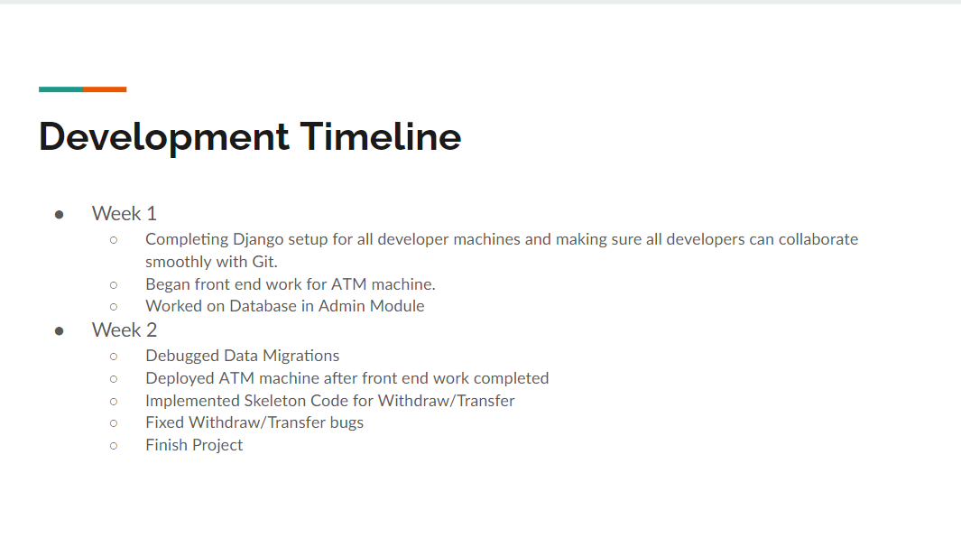

# Test

## Test Cases

|  |  |  |  |
| --- | --- | --- | --- |
| **ATM Test Cases** | | | |
| Function | Features | Tested | Verdict |
| user_login | allows the user to log in with valid credentials | wrong username, wrong password, both wrong | pass |
| user_log_out | lets the user log out | log out | pass |
| user_account_panel | display all the options the user has | clicking on cards, log out, and all 9 buttons | pass |
| deposit | verifies card and pin, and deposits specified amount | wrong pin, wrong card, both wrong, negative amount, too much, too little | pass |
| withdrawal | verifies card and pin, and deposits specified amount | wrong pin, wrong card, both wrong, negative amount, too much, too little, not enough | pass |
| transfer | sends a specified amount of money from one card to another | wrong pin, wrong card, both wrong, negative amount, too much, too little, not enough | pass |
| block_card | blocks a selected card | check if both pin and card number exist, set card to inactive, already blocked, | pass |
| activate_card | activates a selected card | check if both pin and card number exist, set card to active, already activated | pass |
| reset_pin | resets the card pin | check if both pin and card number exist, no change if blocked | pass |
| update_phone | updates phone number | check if both pin and card number exist, change phone number | pass |
| view_history | displays transaction history | check if both pin and card number exist, checks if no history exists | pass |
| update_expd | updates expiration date | check if both pin and card number exist to update | pass |
| admin_log_in | allows the admin to login | check if both pin and card number exist to allow access to the admin | pass |
| admin_log_out | lets the admin log out | log out | pass |
| admin_account_panel | display the options available to admin | test accessing accounts, cards, atm status, change, logout | pass |
| card_details | display all the card details | test displaying every field for the user’s card | pass |
| account_details | display all the user details | test displaying every field for the user’s card | pass |
| atm_status | shows the status of the atm | display all the fields for the atm, and return | pass |

# Screenshots

## 

* + 
   